

**Coding challenge solved by**

Guilherme Martins

The document aim is to show the necessary requirements and dependencies to run the script as well as explain how to run.

**Overall Process:**

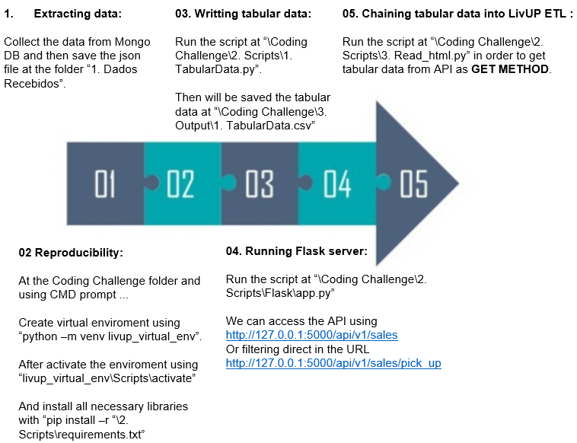

**Folder Structure:**

In the root folder (Coding Challenge folder) there are 4 subfolders as shown in the picture below.

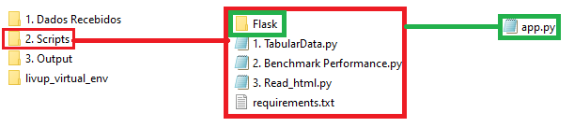

Note: There is script called “2. Benchmark Performance.py” which was used to evaluate how well the programming was running for 1000 sales json file.

**Specs used in the project:**

* Windows 10
* Python 3.7.1 64-bit
* Visual Studio Code

**Libraries used in the project:**

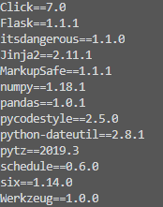

Note: There is requirements.txt file at “\Coding Challenge\2. Scripts”.